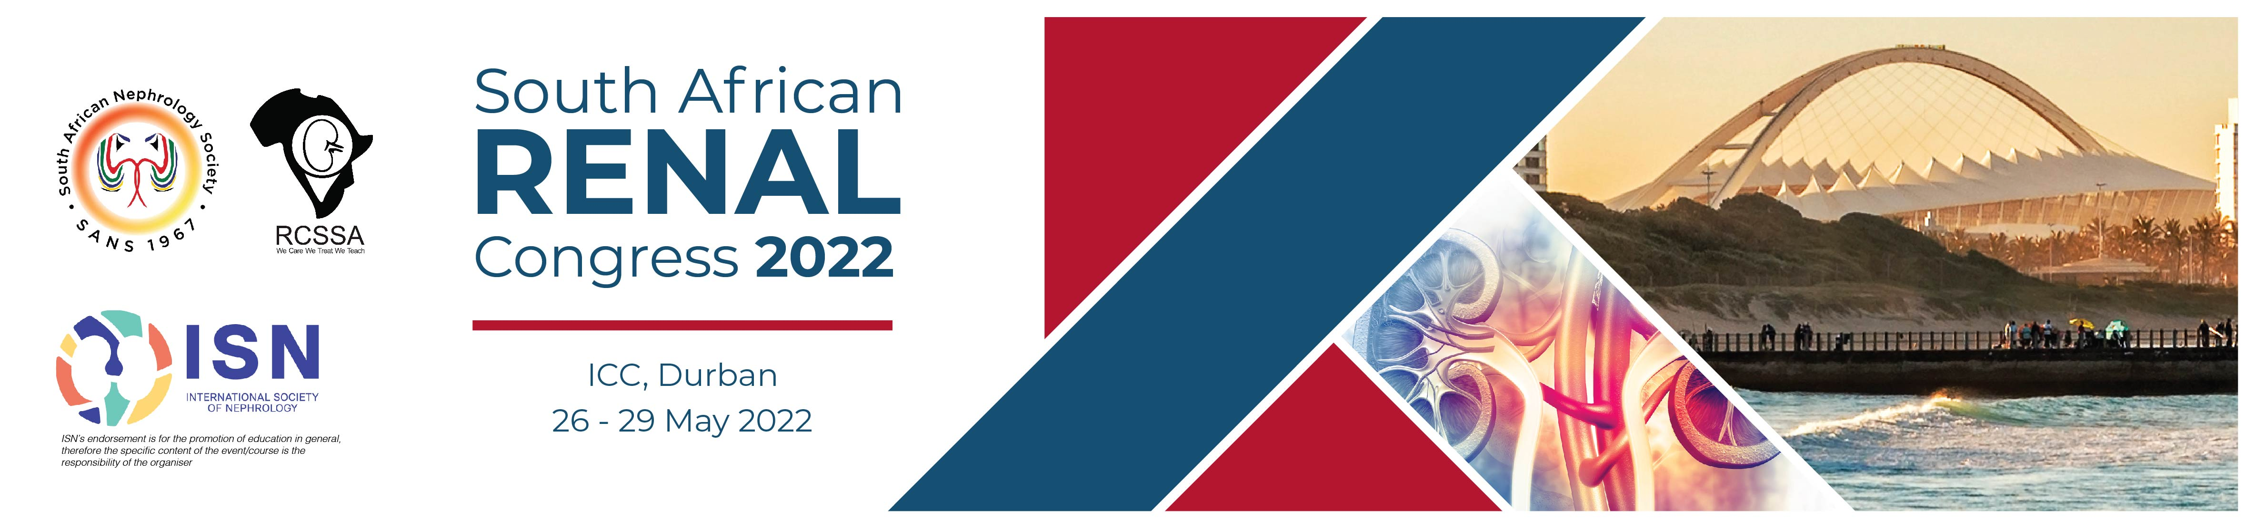

TRANSFER BOOKING FORM
Transfers - SA Renal Congress 2022
SOUTH AFRICAN RENAL CONGRESS 2022
26 – 29 May 2022, Inkosi Albert Luthuli International Convention Centre, Durban, SOUTH AFRICA
To register, kindly complete one form, per delegate and email, fax or post it to Turners Conferences & Conventions (Pty) Ltd
Email: DeveenaN@turnersconferences.co.za, Fax: 086 664 4764, Tel: 031 368 8000
DELEGATE INFORMATION
Last Name/Family Name |  |  | First Name |  |  |  |  |  |  |  |  |  |  |  | Title: Prof/Dr/Ms/Mrs./Mr. |  |  |  |  |  |  |  | Nationality
ACCOMPANYING PERSONS
Number |  |  | Last Name/Family Name |  |  |  |  |  |  |  |  |  |  |  | First Name |  |  |  |  |  |  |  | Title: Prof/Dr/Ms/Mrs./Mr |  |  |  | Nationality
1
2
3
4
5
6
7
Tick as required: This is my: |  |  |  |  |  | Private Address |  |  |  |  |  |  |  | Institution Address |  |  |  |  |  |  |  | Please fill in the relevant details below
Institution Name
Institution Vat Number
Department
Contact Person’s Name
Postal Address
City |  |  |  |  |  |  |  |  |  |  |  | State |  |  |  |  |  |  |  | Post / Zip Code
Country |  |  |  |  |  |  |  |  |  |  |  | Phone |  |  |  |  |  |  |  | Mobile
Email Address (Please Print) |  |  |  |  |  |  |  |  |  |  |  |  |  |  |  |  |  |  |  | Fax
Special Dietary and Other Requests:
Dietary / Other |  | Name |  |  |  |  |  |  |  |  |  |  |  |  |  | Request
A AIRPORT TRANSFERS
If you would like to book transfers between King Shaka International Airport and the appointed accommodation in the City or Durban Beachfront, please fill out the details below. A pre-booked and pre-paid transfer costs R475.00 per person, one way. Transfers not paid in full by the 26 April 2022, will be cancelled automatically. These will need to be re-booked with full payment to secure the services.
Date of Transfer | Pick Up Point |  |  |  |  |  |  |  |  | Flight Number |  |  | Flight Arrival or Departure Time |  |  |  |  | Drop off Point |  |  |  |  |  | No. of  People |  | Cost
 | King Shaka Int. Airport |  |  |  |  |  |  |  |  |  |  |  |  |  |  |  |  |  |  |  |  |  |  |  |  | R
 |  |  |  |  |  |  |  |  |  |  |  |  |  |  |  |  |  | King Shaka Int. Airport |  |  |  |  |  |  |  | R
Total Transfer Cost |  |  |  |  |  |  |  |  |  |  |  |  |  |  |  |  |  |  |  |  |  |  |  |  |  | R
Arrival Airport Information: On arrival at King Shaka International Airport; collect your luggage and proceed to the main arrivals’ hall. Look out for a representative from ZAF Travel & Tours who will be holding a board with your name on it. Should you encounter problems locating the Meet and Greet representative; please call the contact numbers available on your transfer voucher.

Cancellation policy: All transport is subject to Turners and their appointed service providers’ terms and conditions. Once confirmed, transfers will be subject to a 100% (percent) cancellation fee if cancelled within 48 hours of the service date, without reasonable cause or beyond the delegates’ control i.e. flight delay or cancelled flight.
An amendment fee of R230.00 applies to all changes made to confirmed reservations. The above conditions apply unless otherwise specified in writing.
TOTAL AMOUNT PAYABLE
(Use this section to summarize your requirements and calculate the total of your payments due)
Sections |  |  |  |  |  |  |  |  |  |  |  |  |  |  |  |  |  |  |  |  |  |  |  |  |  | R Amount
A Airport Transfers |  |  |  |  |  |  |  |  |  |  |  |  |  |  |  |  |  |  |  |  |  |  |  |  |  | R
TOTAL |  |  |  |  |  |  |  |  |  |  |  |  |  |  |  |  |  |  |  |  |  |  |  |  |  | R
PAYMENT DETAILS
Please enter X in the appropriate box
Option 1  Bank Transfer |  |  |  |  |  |  |  |  | You must specify your full name and SARS 2022 Conference on your bank transfer. Forward to:  Turners Conferences and Conventions (Pty) Ltd  Bank: ABSA Bank  Branch: ABS Premium 1  Account Name: Turners Conferences & Conventions (Pty) Ltd  Account Number: 4060455419  Branch Code: 632005  Swift Code: ABSA-ZA-JJ  (Please fax a copy of your bank transfer to Turners).  Final date for bank transfers will be the 19 May 2022.  When processing your payment by bank draft please allow additional funds to cover bank charges. If short payments are received, these will be for your account.
Option 2  Credit Card |  |  |  |  |  |  |  |  | When opting to process payment by credit card, further instructions will be emailed advising on how to process payment via the online 3D PayGate Portal. A unique reference number will be issued to you

Please complete this booking form and submit it to the Turners Conferences:
Turners Conferences (Pty) Ltd
PO Box 1935, Durban, 4000 South Africa
Telephone: | +27 31 368 8000
Fax: | +27 31 368 6623
Email: | Gills@turnersconferences.co.za

All transactions are conducted in terms of Turners Conferences standard conditions of trading. They are published on the Turners Conferences website & available on application.
All published prices are subject to change without prior notice, this may be due to currency regulations and/or changes in duties or taxes.
Without the complete documents, we are unable to process your booking.
Your booking will only be confirmed once payment has been received.

