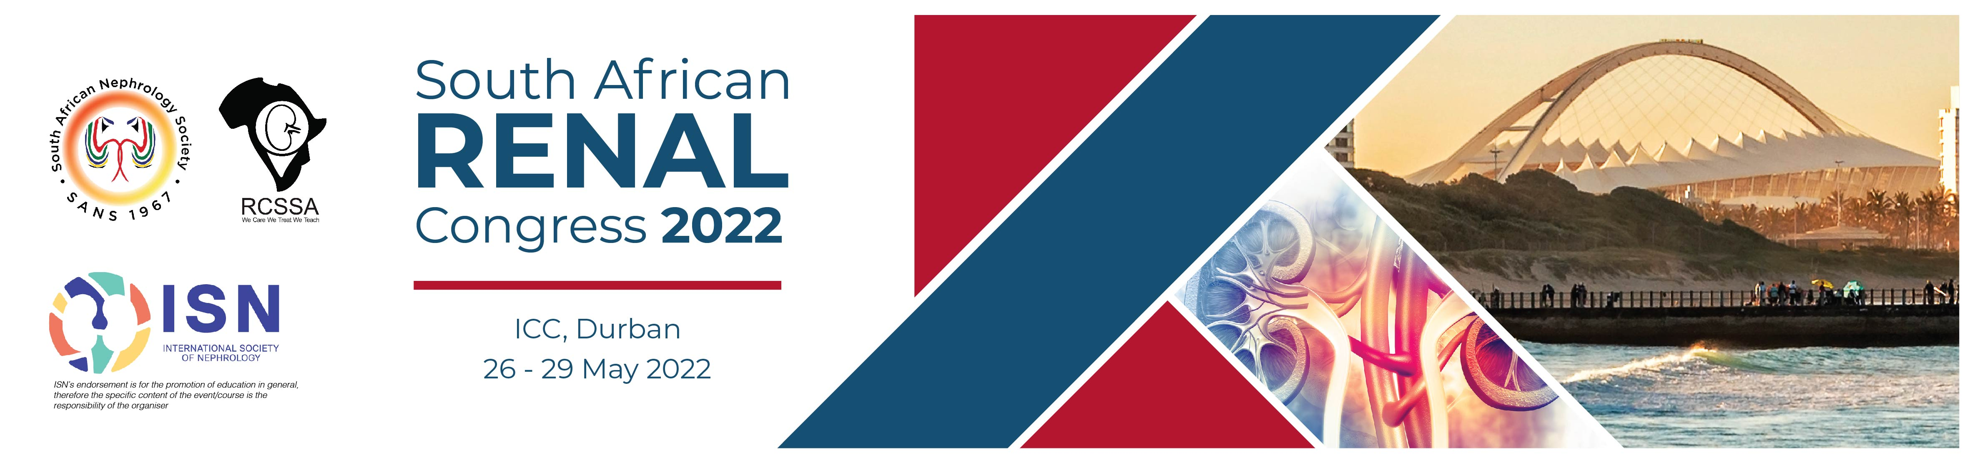

TOUR BOOKING FORM
SA Renal Congress 2022
SOUTH AFRICAN RENAL CONGRESS 2022
26 – 29 May 2022, Inkosi Albert Luthuli International Convention Centre, Durban, SOUTH AFRICA
To register, kindly complete one form, per delegate and email, fax or post it to Turners Conferences & Conventions (Pty) Ltd
Email: DeveenaN@turnersconferences.co.za, Fax: 086 664 4764, Tel: 031 368 8000
DELEGATE INFORMATION
Last Name/Family Name |  |  |  | First Name |  |  |  |  |  |  | Title: Prof/Dr/Ms/Mrs./Mr. |  |  |  |  |  |  | Nationality
ACCOMPANYING PERSONS
Tick as required: This is my: |  | Private Address |  |  |  |  |  |  | Institution Address |  |  |  |  |  |  | Please fill in the relevant details below
Institution Name
Department
Contact Person’s Name
Postal Address
City |  |  |  |  |  |  |  | State |  |  |  |  |  |  | Post / Zip Code
Country |  |  |  |  |  |  |  | Phone |  |  |  |  |  |  | Mobile
Email Address (Please Print) |  |  |  |  |  |  |  |  |  |  |  |  |  |  | Fax
Special Dietary and Other Requests:
Dietary | Name |  |  |  |  |  |  |  |  | Request
Other | Name |  |  |  |  |  |  |  |  | Request
EXCURSION PROGRAMME
Please select the tour of your choice from the website and complete the tour booking section. A deposit of 20% of the total tour value is required within 14 days of booking to confirm the tour reservation. The balance of the tour price must reach Turners Conferences 45 days prior to the tour departure date. Any tours booked within 45 days of the departure date must be paid in full immediately.
Excursion Name |  |  |  |  |  | Date of Tour |  |  |  |  |  | Cost per person |  |  |  |  | No of People |  |  |  | Cost
 |  |  |  |  |  |  |  |  |  |  |  |  |  |  |  |  |  |  |  |  | R
 |  |  |  |  |  |  |  |  |  |  |  |  |  |  |  |  |  |  |  |  | R
 |  |  |  |  |  |  |  |  |  |  |  |  |  |  |  |  |  |  |  |  | R
Excursion Total |  |  |  |  |  |  |  |  |  |  |  |  |  |  |  |  |  |  |  |  | R
Special Notes: (Sharing partner, dietary requirements, etc.):
All tours are subject to Turners and their appointed tour operators’ terms and conditions. Once confirmed, tours will be subject to a cancellation fee if cancelled before 24 April 2022. No refunds will be made for cancellations received after 24 April 2022.

Cancellation fees: Refunds will be permitted for bookings cancelled within the following time periods, prior to departure:
More than 90 Days: Full refund less R230.00 administration fee per tour
90 Days & 60 Days: Full tour price less 20%
60 Days & 30 Days: Full tour price less 50%
30 Days & 0 Days: No refund

An amendment fee of R230.00 applies to all changes made to confirmed reservations. The above conditions apply unless otherwise specified in writing.
TOTAL AMOUNT PAYABLE
(Use this section to summarize your requirements and calculate the total of your payments due)
Sections |  |  |  |  |  |  |  |  |  |  |  |  |  |  |  |  |  |  |  |  |  | R Amount
A Excursion Programme |  |  |  |  |  |  |  |  |  |  |  |  |  |  |  |  |  |  |  |  |  | R
TOTAL |  |  |  |  |  |  |  |  |  |  |  |  |  |  |  |  |  |  |  |  |  | R
PAYMENT DETAILS
Please enter X in the appropriate box
Option 1  Bank Transfer |  |  |  |  | You must specify your full name and SA Renal Conference 22 on your bank transfer. Forward to:  Turners Conferences and Conventions (Pty) Ltd  Bank: ABSA Bank  Branch: ABS Premium 1  Account Name: Turners Conferences & Conventions (Pty) Ltd  Account Number: 4060455419  Branch Code: 632005  Swift Code: ABSA-ZA-JJ  (Please fax a copy of your bank transfer to Turners).  Final date for bank transfers will be the 19 May 22  When processing your payment by bank draft please allow additional funds to cover bank charges. If short payments are received, these will be for your account.
Option 2  Credit Card |  |  |  |  | When opting to process payment by credit card, further instructions will be emailed advising on how to process payment via the online 3D PayGate Portal. A unique reference number will be issued to you

Please complete this booking form and submit it to the Turners Conferences:
Turners Conferences & Conventions (Pty) Ltd
PO Box 1935, Durban, 4000 South Africa
Telephone: | +27 31 368 8000
Fax: | +27 31 368 6623
Email: | Gills@turnersconferences.co.za

All transactions are conducted in terms of Turners Conferences standard conditions of trading. They are published on the Turners Conferences website & available on application.
All published prices are subject to change without prior notice, this may be due to currency regulations and/or changes in duties or taxes.
Without the complete documents, we are unable to process your booking.
Your booking will only be confirmed once payment has been received.

